# NITTE MEENAKSHI INSTITUTE OF TECHNOLOGY

**Yelahanka, Bangalore - 560 064**

**DEPARTMENT OF INFORMATION SCIENCE AND ENGINEERING**

**DATA BASE MANAGEMENT SYSTEM**

**PROJECT: BANK DATABASE MANAGMENT**

TEAM : SHRIMAN - 1NT19IS150

SHWETHA – 1NT19IS152

VIDYASHREE – 1NT19IS185

VISHWAS S NAYAK – 1NT19IS193

## TABLE OF CONTENTS

Contents ....................................................................................................................................... i

1. Introduction ............................................................................................................................
   1. Problem Definition ..........................................................................................................
   2. Scope & Importance ........................................................................................................
2. Software Requirement Specification ......................................................................................
   1. Functional Requirements ................................................................................................
   2. Software Requirements ....................................................................................................
   3. Hardware Requirements .................................................................................................
3. System Design .......................................................................................................................
   1. ER Model .......................................................................................................................
   2. Schema Description .......................................................................................................
   3. Relational Schema .........................................................................................................
4. Prototype ...........................................................................................................................
5. Conclusion and Way Forward………………………………………………………………

## INTRODUCTION

BANK is one of the most secured place where people save their money and they are allowed to take

their money when ever they need. Bank has even more features like it provides loan to the customer

and it provides ATM card using which the customer of the bank can withdraw their money by visiting

to the nearest ATM machine and now a days everything is digital so the customer can transfer the

money among them and even send money to or receive money from other bank customers. Thus

BANK has become one of the most important thing in our life.

### 1.1 Problem Definition

BANK is a safe and secure place to our money. But bank also stores our personal information

which also need to be secured from others. This information must not be visible by other

customers or any other person out of bank. It should be visible and editable only by the bank employees and the bank manager.

### 1.2 Scope & Importance

The main scope and importance of our project is to provide the security to the bank customers and employees personal information and also to provide the loan to our customers and encourage them to stay connected with our bank. Trust is the most difficult thing to gain in this current world. To gain trust we must provide them a good security then only anyone will trust us and our bank. So the main aim of this project deals with storing and securing the information of the bank customers…

## Software Requirement Specification

### 2.1 Functional Requirements Specification

A functional requirement document defines the functionality of a system or one of its subsystems. It also depends upon the type of software, expected users and the type of system where the software is used. The functional user requirements may be high level statements of the system should do but functional system requirements should also describe clearly about the system services in detail.

LOGIN : The login page has 3 logins 1.Manager login

2.Customer login

3.User login

MANAGER : Manager is plays the important role where in he can create edit and remove Employee and Customer Account and grant loan to the Customer. And Manager can view his details

EMPLOYEE : Employee can create , edit and remove customer account and he can apply for loan if the customer request for the loan. And he can view details of his own Account.

CUSTOMER : Customer can view his information stored in the bank database.

### 2.2 Software Requirements Specification

**Operating System:** Windows 7 or higher

**Database:** XAMPP

**IDE:** Visual Studio Code

**Language:** HTML, CSS, PHP, JavaScript

### 2.3 Hardware Requirements Specification

**Installed Memory (RAM):** 2GB or higher

**Processor:** 1GHz or higher

**Hard disk Space:** 20 GB availability

**Display:** Standard output display

## SYSTEM DESIGN

### ER Model

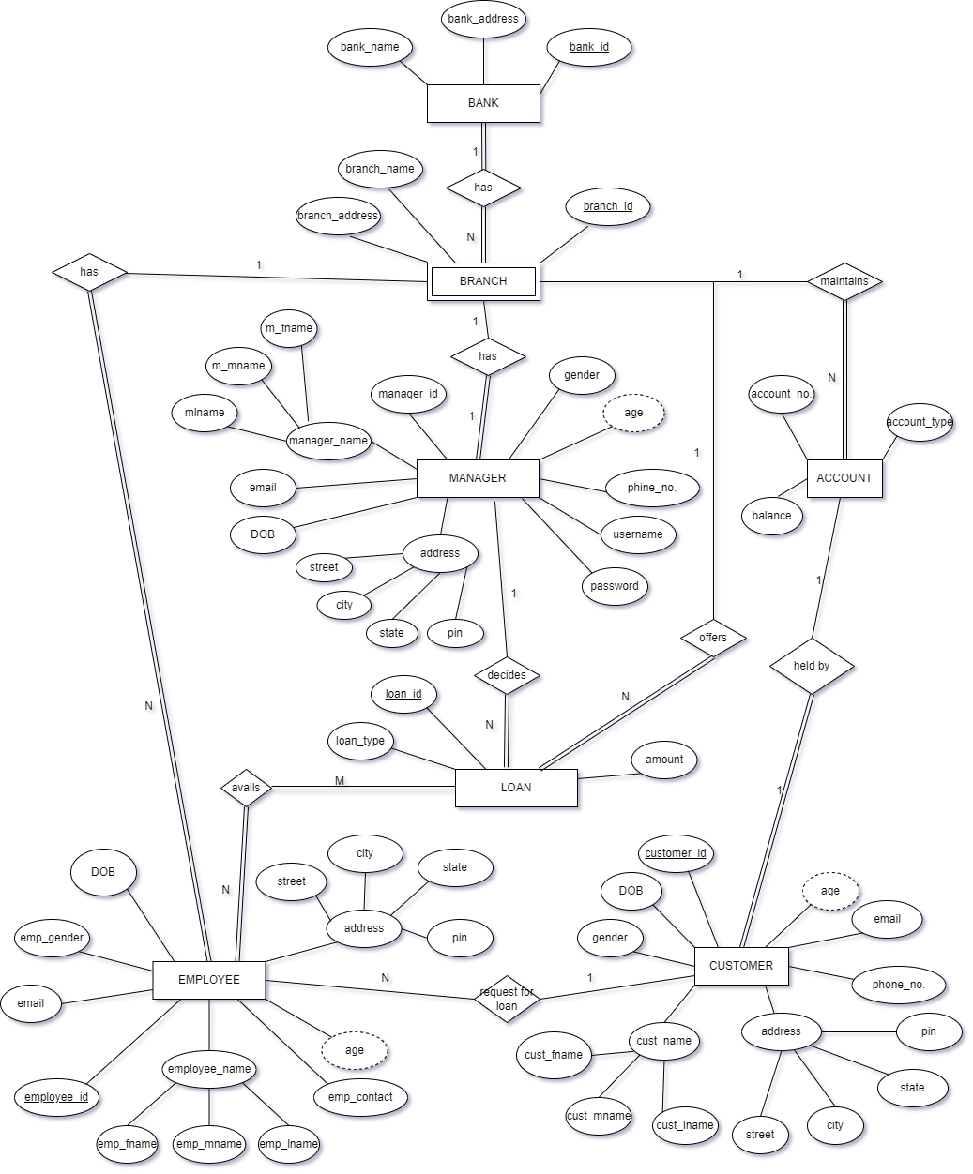

### Schema Diagram

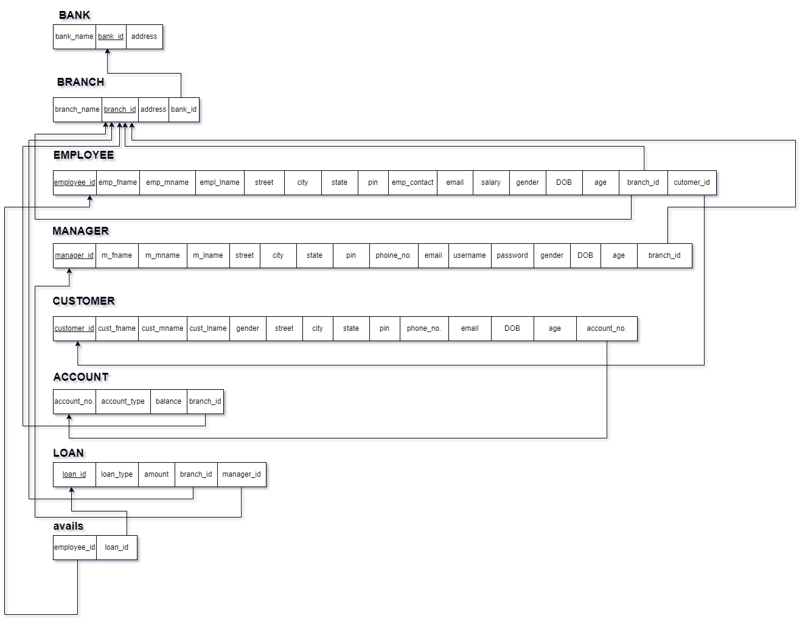

### Relational Schema

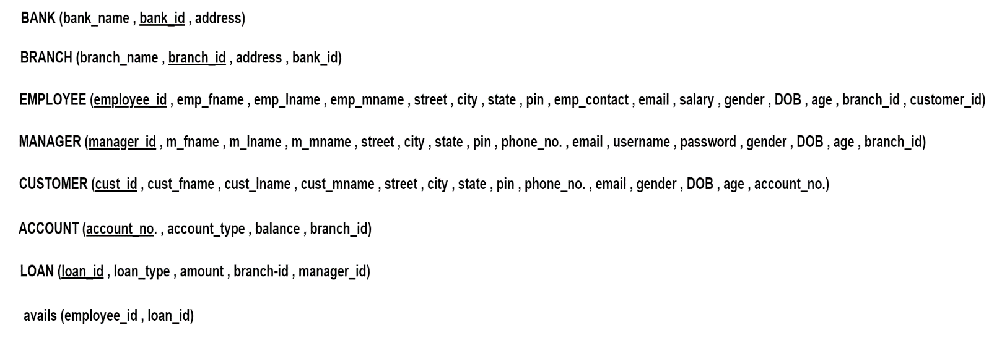

## PROTOTYPE

* BANK LOGIN

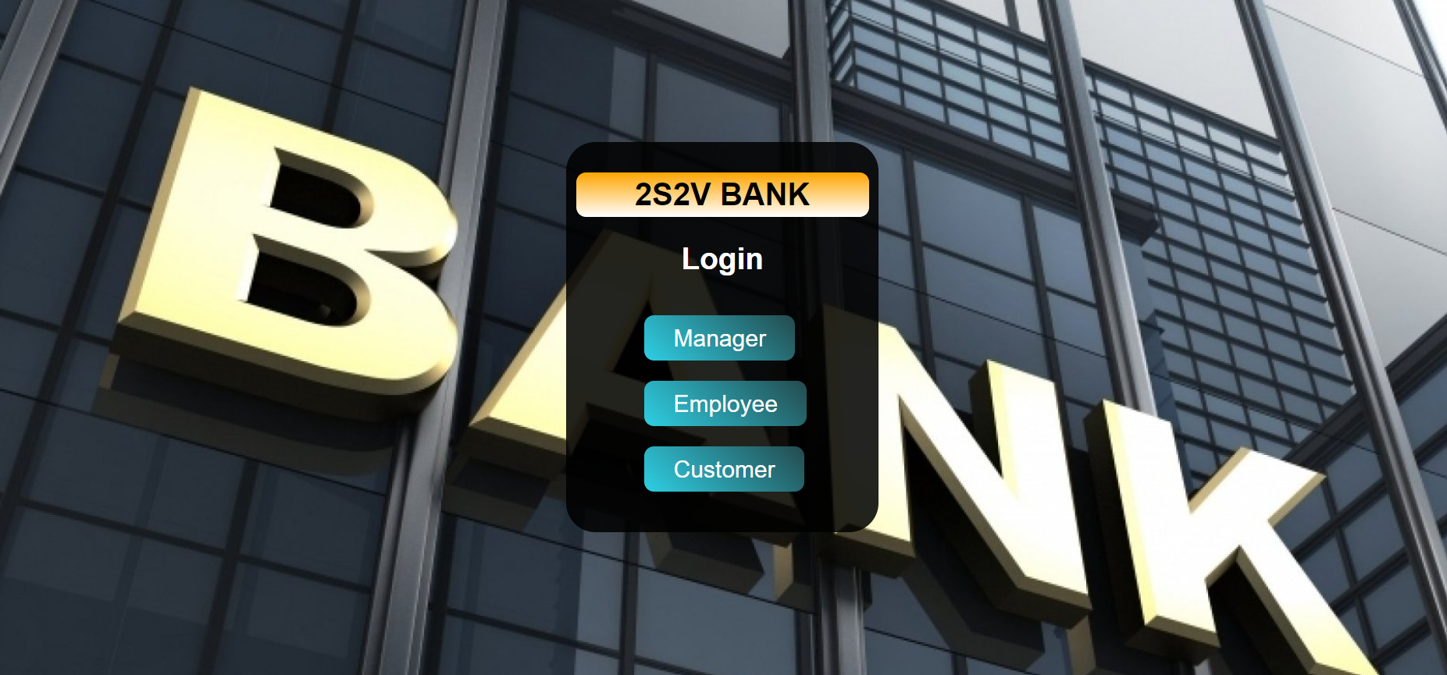

* MANAGER, EMPLOYEE AND CUSTOMER LOGIN

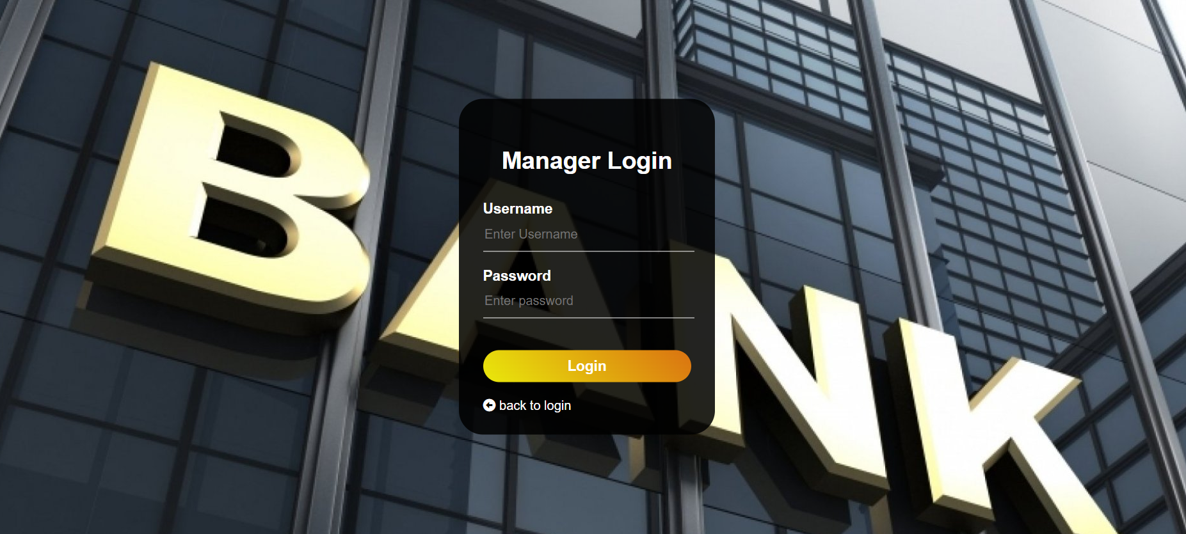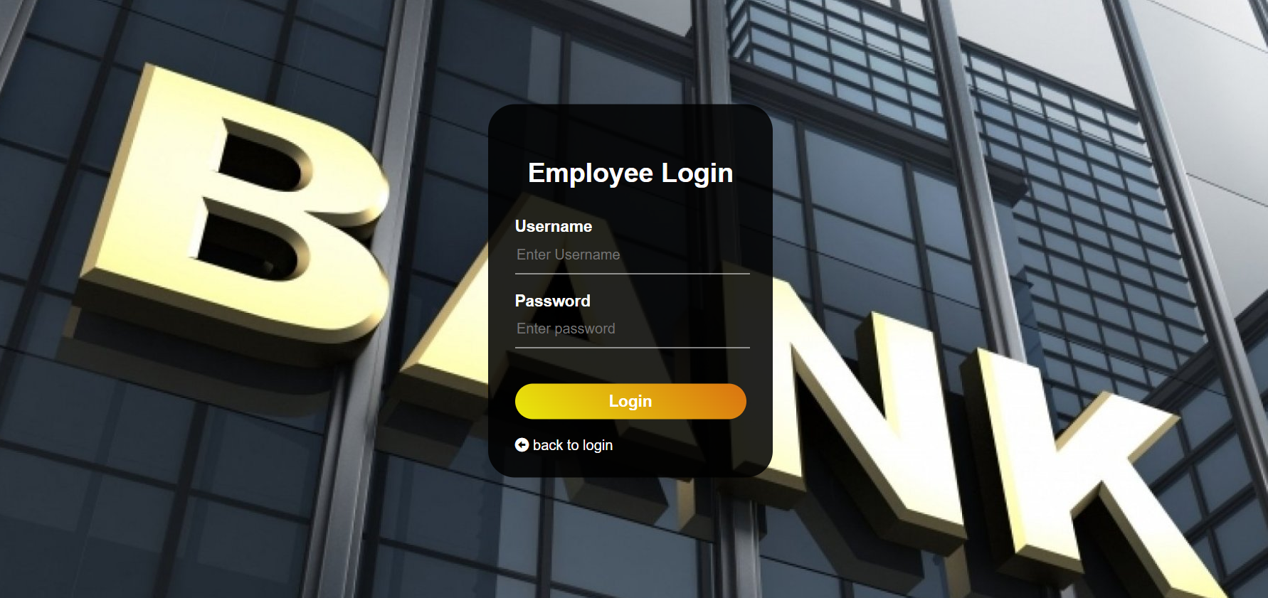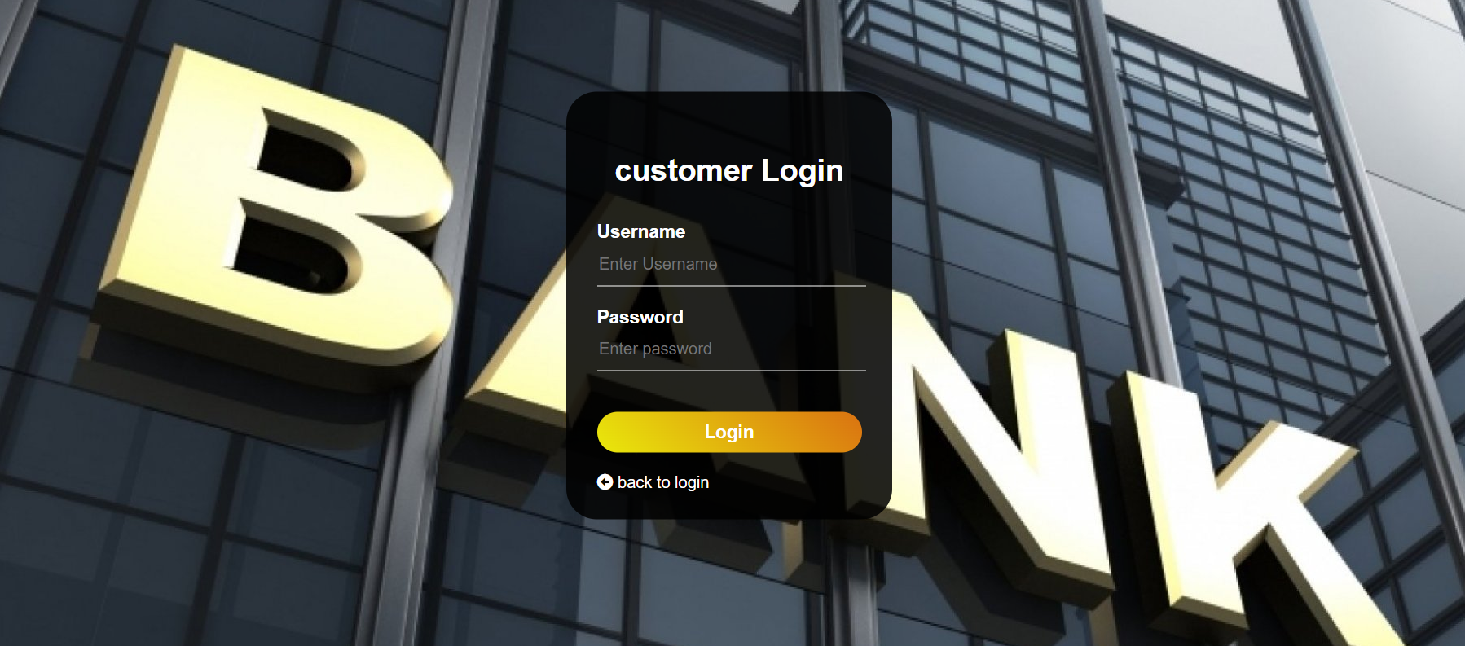

* MANAGER, EMPLOYEE AND CUSTOMER HOME

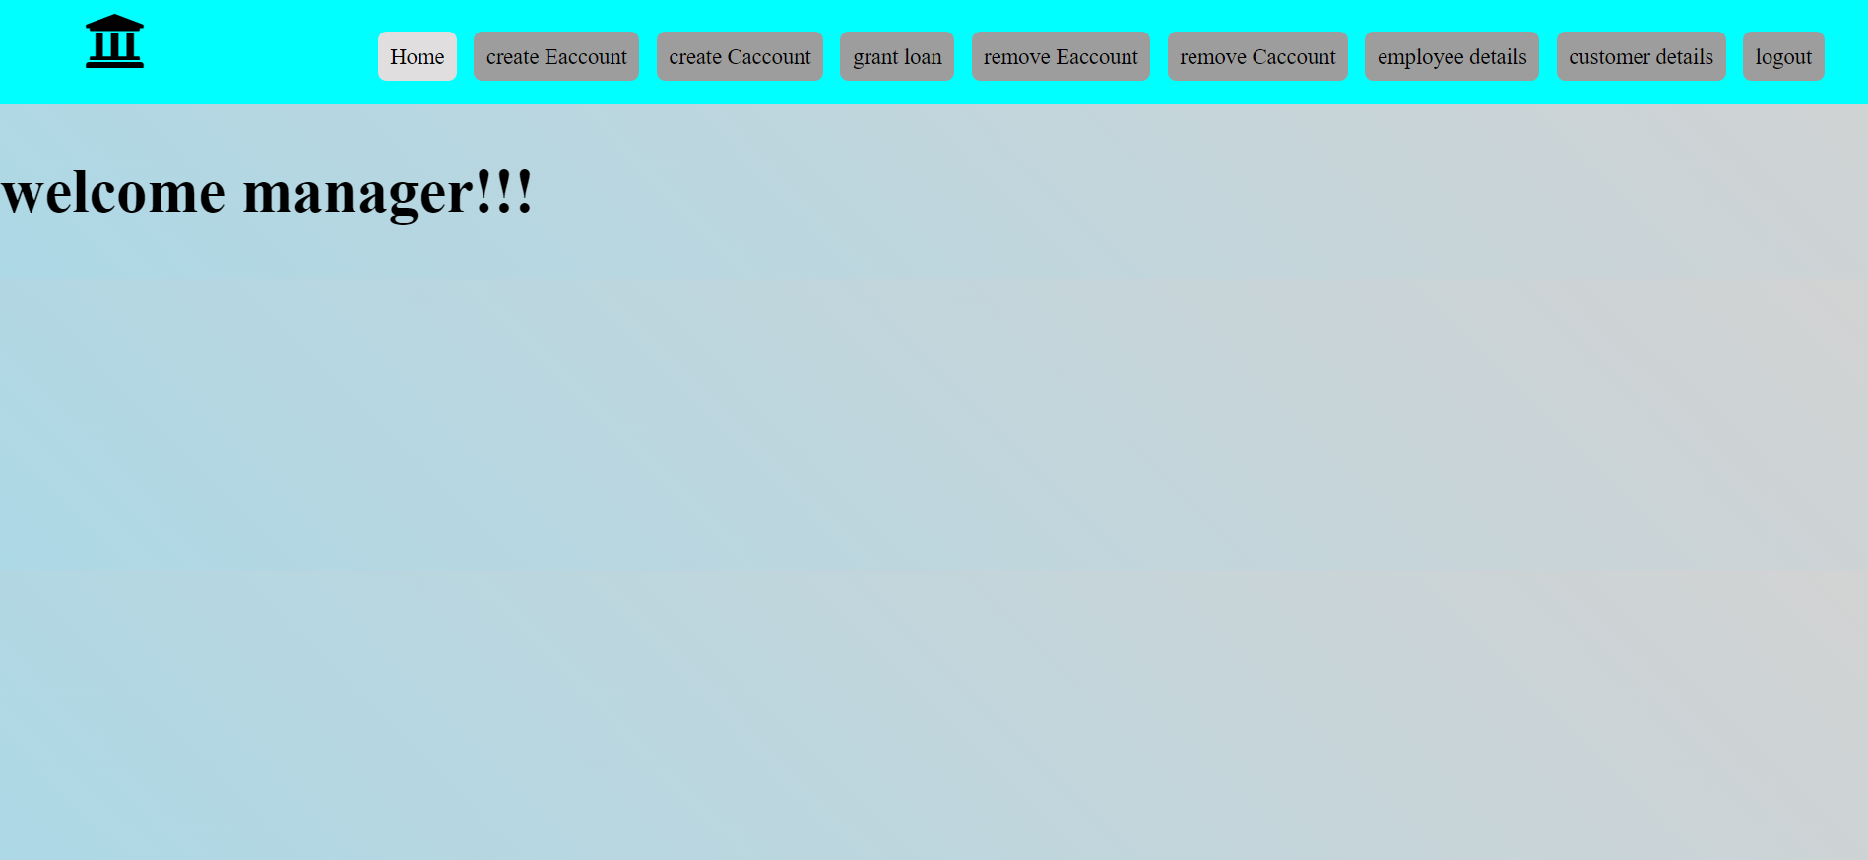

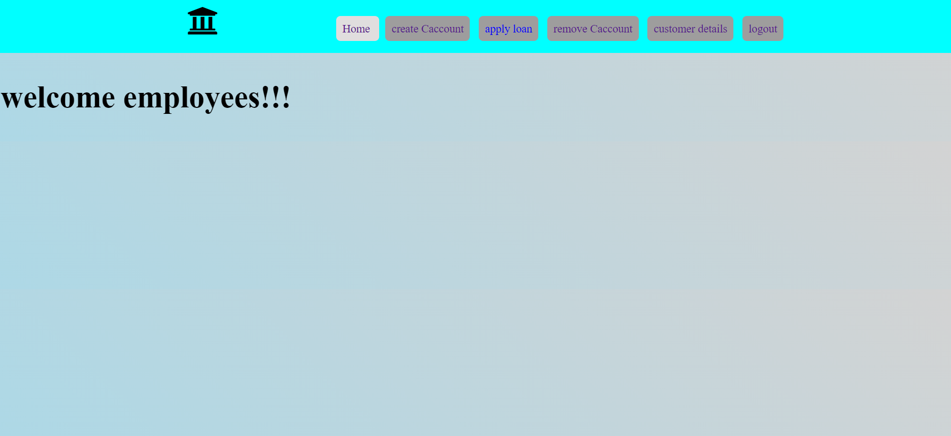

* NEW ACCOUNT CREATE

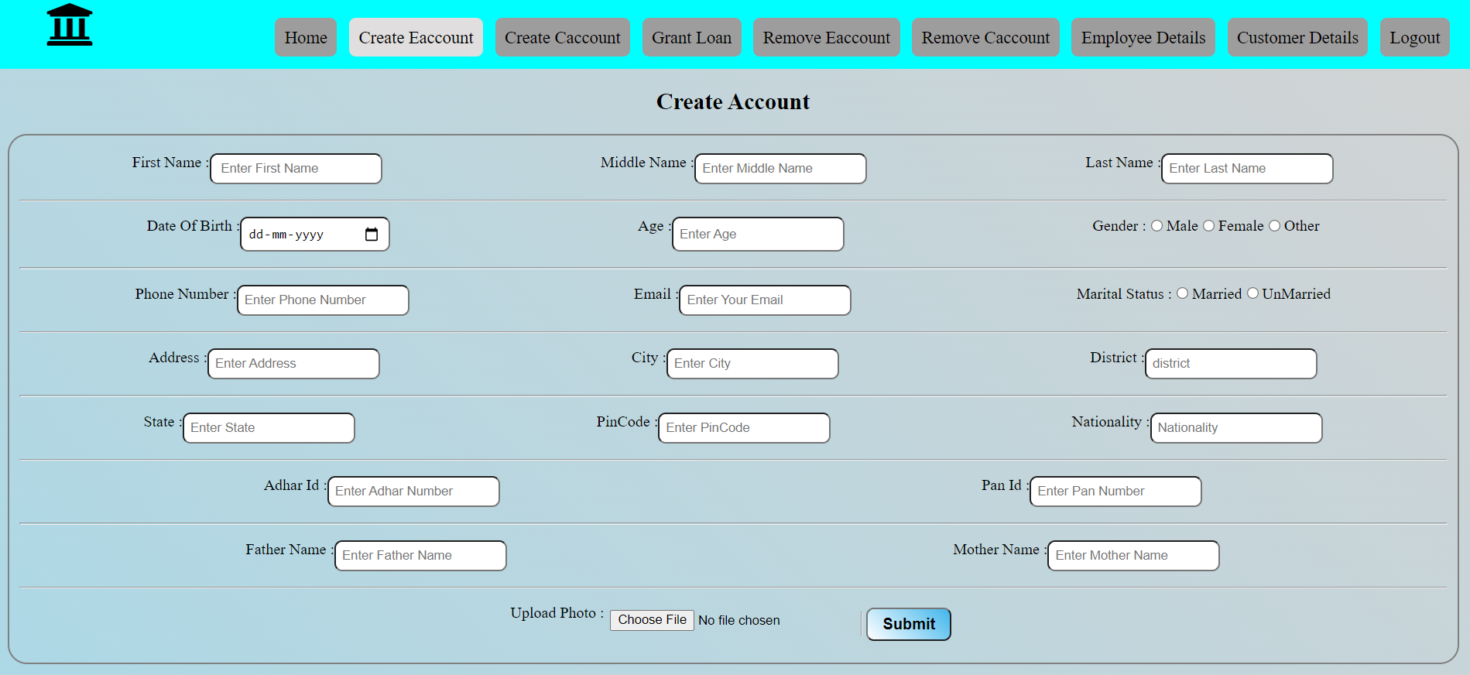

* REMOVE EMPLOYEE ACCOUNT (by only manager)

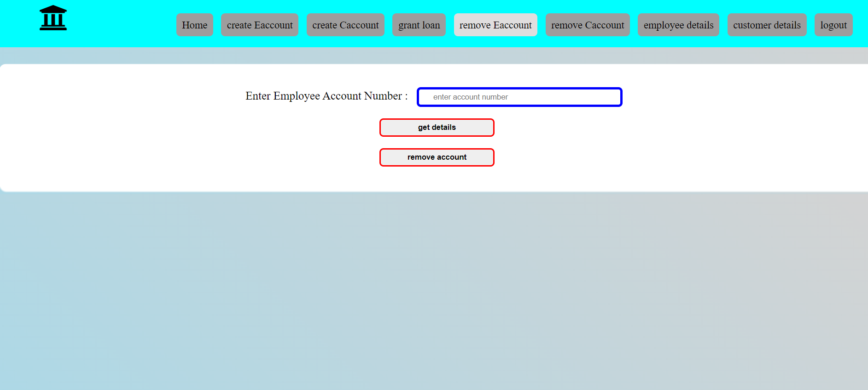

* REMOVE CUSTOMER ACCOUNT (by both manager and employee)

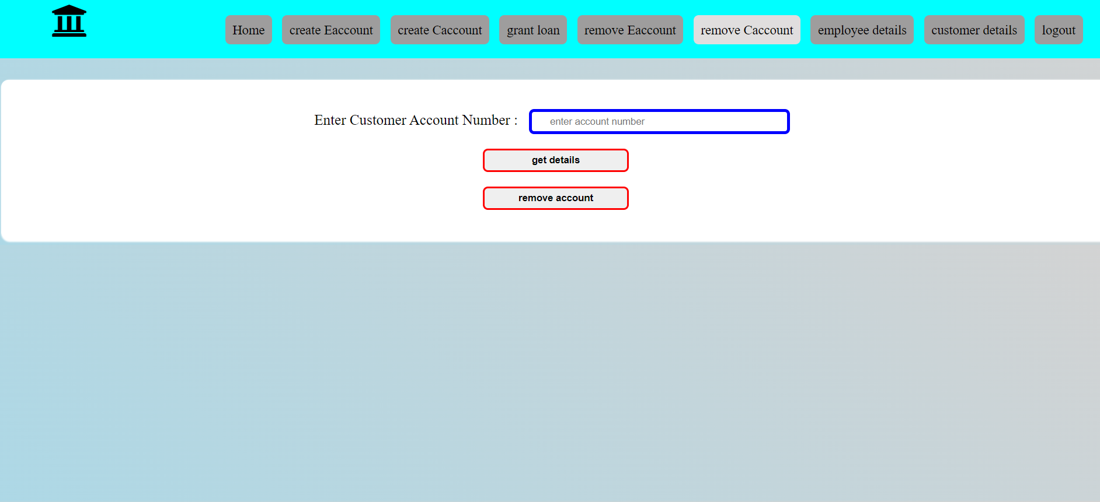

* FETCHING ACCOUNT DETAILS OF EMPLOYEE (only by manager)

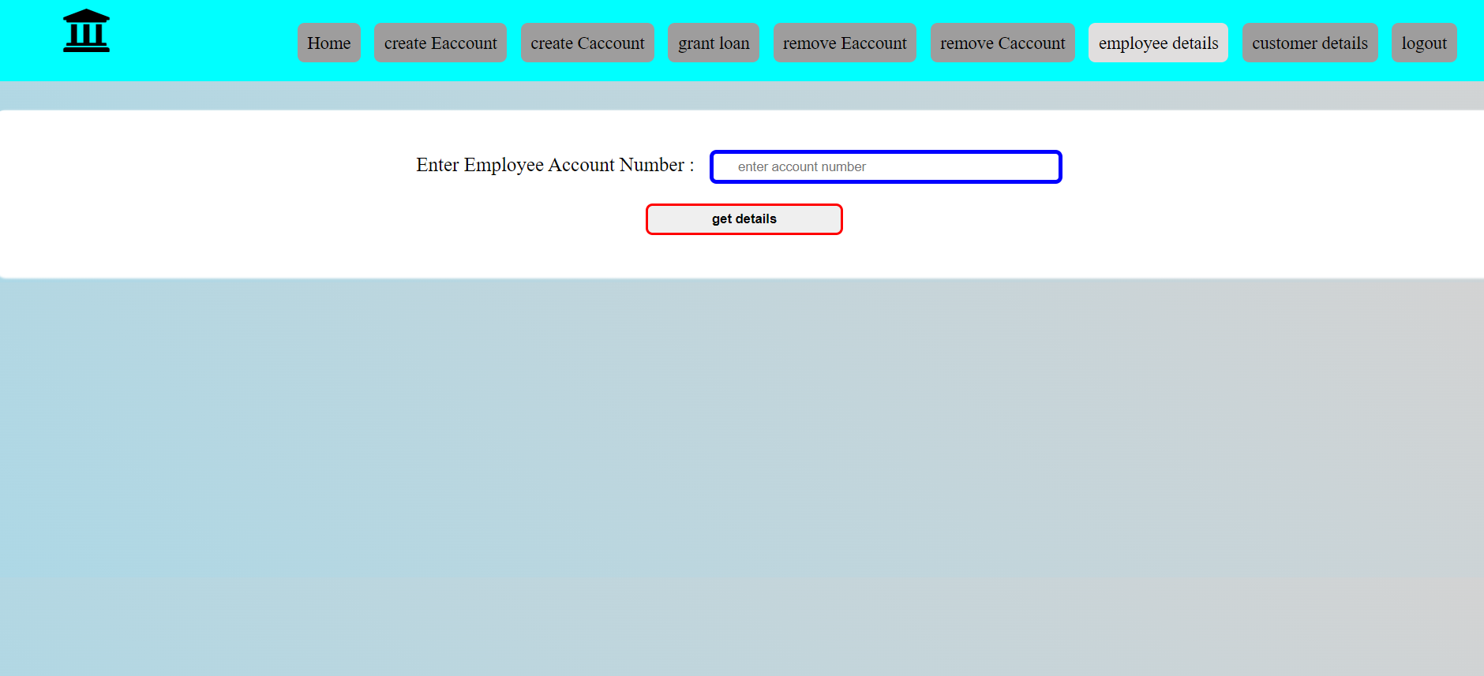

* FETCHING CUSTOMER ACCOUNT DETAIL (by manager and employees)

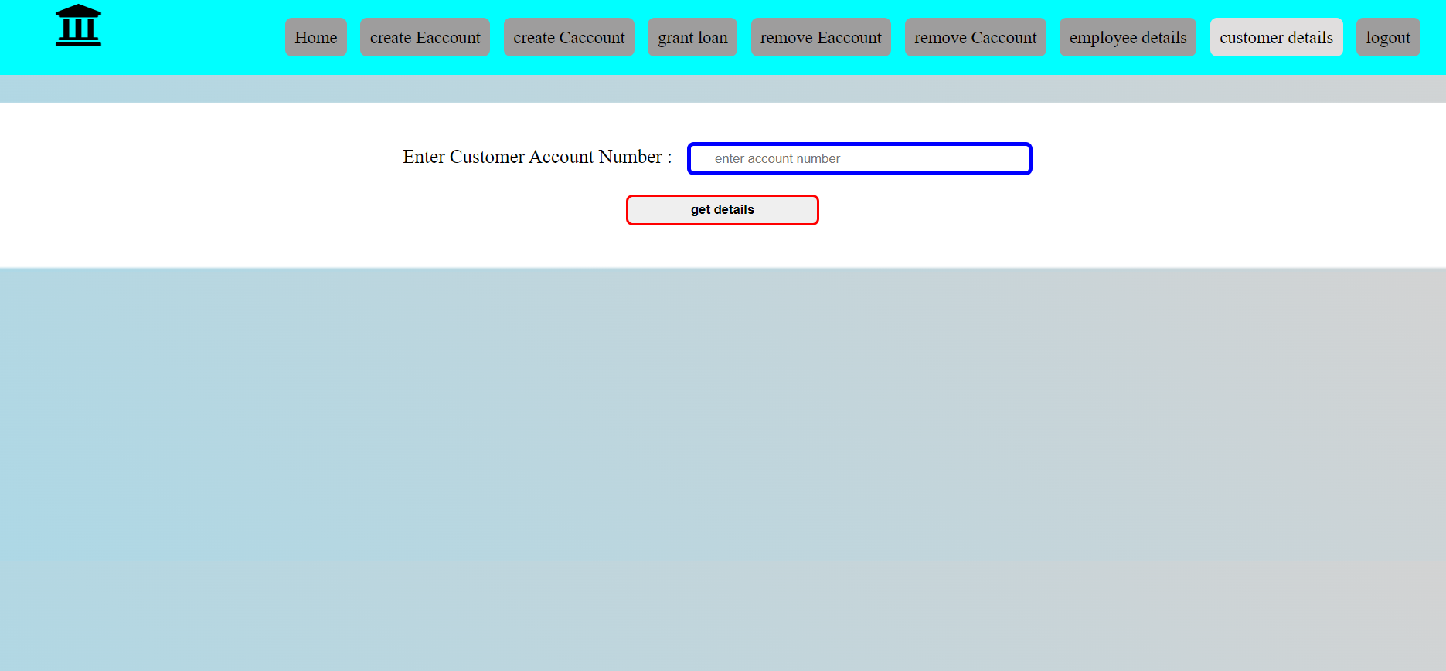

**CONCLUSION AND WAY FORWARD**

The introduction ,problem definition of the project has been completed successfully to college web-based bank database management system by maintaining the manager, employee and customer details related to banking in a efficient manner.

Our project has a big scope to do. Here we store the details of the Manager, Employee and Customer related to Banking. It is a Secure way to store the details of the account information. Here manager is one who has access to all fields related to Employees and Customers. Employees have access to fields related to all Customers of the bank. Customer has access to only fields related to their account.Thus our project provides a secure and structured database for the BANK.